Dear, Homer Simpson!
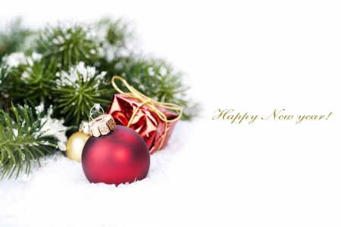
Happy New Year!

Dear, Marge Simpson!
Happy New Year!

Dear, Bart Simpson!
Happy New Year!

Dear, Lisa Simpson!
Happy New Year!

Dear, Maggie Simpson!
Happy New Year!

